University Address:  415 W. College Ave. Apt. #208  State College, PA 16801 |  | J. David Maino  maino@psu.edu 913.961.1658 |  |  |  | Permanent Address:  3200 W. 121st Terr.  Leawood, KS 66209
Objective: | To obtain a permanent position in lighting and electrical systems design.
Education: | The Pennsylvania State University – University Park, PA
 | Major: Architectural Engineering (Lighting and Electrical Systems Design)
 | Degrees: Master and Bachelor of Architectural Engineering
 | Graduation date: May 2006 Current cumulative GPA: 3.62
Experience: | Integrated Design Associates – Santa Clara, CA
 | Electrical Internship
 | May 2005 – August 2005
- Designed daylight systems for commercial and educational facilities
- Managed small and medium size projects alone and under various engineers
- Participated in site visits to examine existing conditions
- Designed electrical systems and fire alarm systems for various building types
- Created Excel program to expedite fire alarm system design
- Presented information about cogeneration and Radiance
 | Envision Advantage, LLC. – Brentwood, TN
 | Mechanical/Electrical/Plumbing Internship
 | May 2004 – August 2004
- Calculated electrical and HVAC loads using Dapper and CHVAC programs
- Designed and layed out lighting and mechanical systems for various types of buildings in CAD
- Sized feeders, branch circuits, panel boards, diffusers, condensers, and air handlers
- Contributed to group design charettes, meetings, and problem solving sessions
- Created and edited lighting, electrical, mechanical, and plumbing drawings in CAD
 | Giffin Interior & Fixture, Inc. – Bridgeville, PA
 | Architectural Millwork Internship
 | May 2003 – August 2003
- Created and edited shop drawings for a variety of types of millwork
- Implemented new estimating software (TakeOff), and taught estimators how to use it
- Maintained company web site (http://www.giffininterior.com)
 | The Hillier Group – Sprint World Headquarters project in Overland Park, KS
 | Architectural Internship
 | November 1998 – August 2001, May 2002 – August 2002
- Punch-listed and back-punched buildings with the architects and alone
- Edited and red-lined shop drawings (millwork, steel, stone, etc.) for review by architect and consultants
- Wrote and prepared documents for issue (Supplemental Instructions, Owner Change Requests, Construction Change Documents, etc.)
- Learned new CAD program (MicroGDS) to assist in the creation of CAD drawings
University Address:  415 W. College Ave. Apt. #208  State College, PA 16801 |  |  | J. David Maino  maino@psu.edu 913.961.1658 |  | Permanent Address:  3200 W. 121st Terr.  Leawood, KS 66209
Thesis: | Building: Tahoe Center for Environmental Sciences  Location: Incline Village, NV  Website: http://www.arche.psu.edu/thesis/eportfolio/current/portfolios/jdm341/  Function: Research and classroom facilities  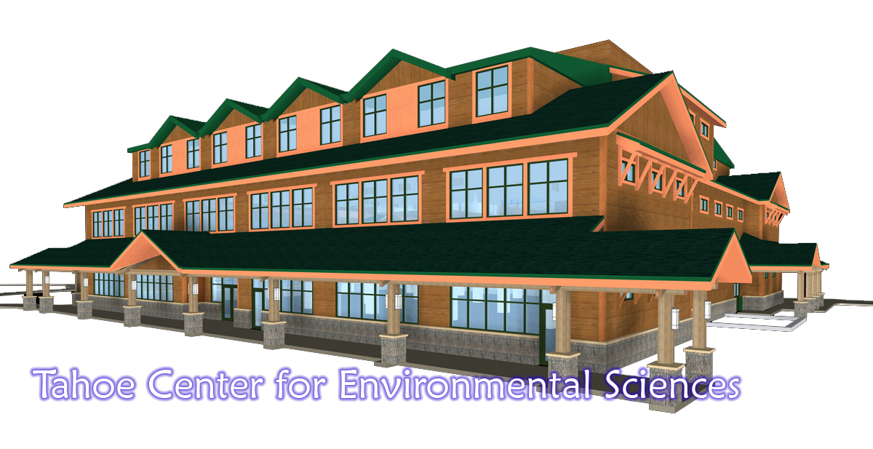  Notable Features:  - LEED Platinum  - Photovoltaics  - Solar hot water heating  - Radiant floor and ceiling panels  - Microturbine cogeneration unit  - Displacement ventilation  - Chilled beam induction ventilation  - Central daylit solarium
Computer Skills: | CAD:  - AutoCAD  - Radiance  - AGI 32  - 3D Studio Viz  - Dapper  - MicroGDS  - CHVAC  - Maya |  |  | Other:  - Debian GNU/Linux  - Adobe PhotoShop, InDesign, Acrobat  - Corel Photopaint  - Microsoft Office (Word, Excel, PowerPoint, FrontPage)  - OpenOffice.org (Writer, Calc, Impress)  - Shell scripting – BASH, CSH
Activities: | - President Illuminating Engineer Society (2005 – present)  - Illuminating Engineer Society (2001 – present)  - Architectural Engineering Envoy (2003 – present)  - Go Club (2004 – present)  - Pride of the Lions basketball pep band (2001 – 2002)  - Recreational Soccer Team (2001 – 2003)
Honors: | - IALD Trust Fund Scholarship  - National Society of Collegiate Scholars  - Schreyer Honors Scholar  - Phi Alpha Epsilon – Architectural Engineering honors society
References: | Available upon request
Portfolio: | Available upon request: digital media or hard copy prints

